The University of Western Ontario

Faculty of Engineering

Department of Electrical and Computer Engineering

Examination Booklet

Family name: Given name: Student number:

Final Examination in Advanced FPGA Designs(ECE616a)
Due April 14 12:00pm
Electronic submission

University policy states that cheating, including plagiarism, on an examination is a scholastic offense. The commission of a scholastic offense is attended by academic penalties which might include expulsion from the program. If you are caught cheating, there will be no second warning.

MARKS Question 1: /10
Question 2: /10
Question 3: /30

Total /50

- (10 marks) Digital design and VHDL

  - Draw the state diagram (minimum states) for the following VHDL code. Is it Moore or Mealy?

Entity state_machine is
Port (sig_in: in BIT; clk : in BIT;
Sig_out : out BIT);
End state_machine;

Architecture state_machine of state_machine is
Type state_type is (A, B, C);
Signal state: statetype := A;
begin
process (clk)
begin
if (clk = ‘1’ and clk’event) then
if (state = A) then
if (sig_in = ‘1’) then
state <= B;
end if;
elsif (state = B) then
if (sig_in = ‘1’) then
state <= C;
end if;
elsif (state = C) then
state <= A;
end if ;
end if;
end process;

with state select
sig_out <= ‘1’ when A,
‘0’ when B,
‘1’ when C;
end state_machine;

  - What is the result of Z for state = 3 and X = ‘1’? (2 marks)
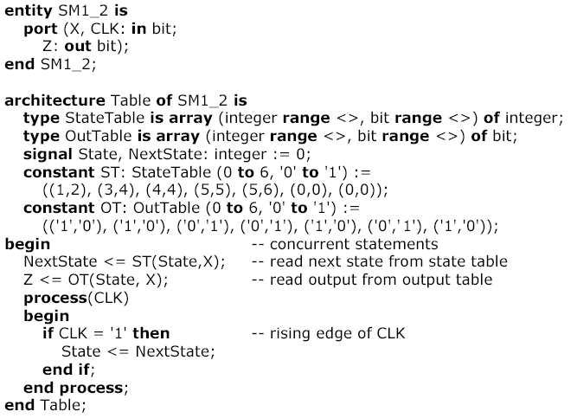

Figure 1

  - Draw the simulation results for the following VHDL code. The propagation delay of each FullAdder is 10 ns. Set A= 1111, B= 0001 and Ci=1, run 40 ns. Then, set A= 0101, B=1110 and Ci=0, run 40 ns. (4 marks)

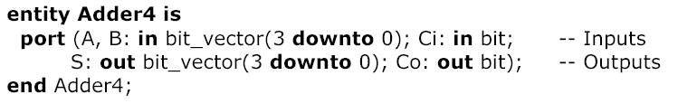

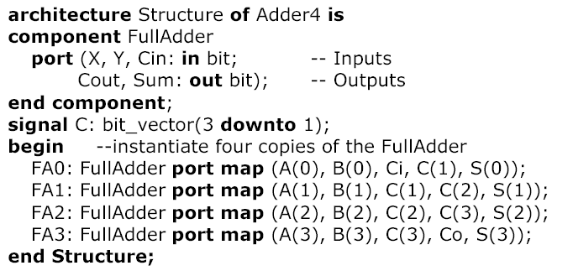

Q2. FPGA and CPLD (10 Marks)
(1) What is I/O bank? Can one I/O bank have different IO standard? Write a page summary of the I/O standard and packaging standards used in Xilinx XC2V1000.
(2) In the following signed multiplier implementation, explain why the MSB of the 1’s complementer’s output is connected to two wires. Furthermore, if the MSB of the multiplier is ‘1’, what is the value of Cm?

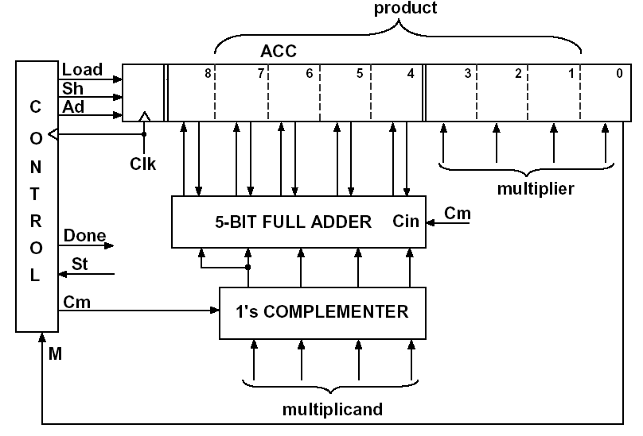

(3) Timing and FPGA IOE
The core of the IOE of Altera is shown below. Assume that if the input X changes, it changes at the same time as the falling edge of the clock. Assuming the following delays: the delay of the OR gate is 5 to 15 ns, inverter 5ns, the propagation delay from the clock to output of the D flip-flop is in the range of 6 to 10 ns, the flip-flop set-up time is 5 ns, and the hold time is 5 ns. Initially assume that the “delay” is 0ns.
- What is the minimum clock period and maximum clock frequency for proper synchronous operation of the IOE?
- Assume a clock period of 100 ns. What is the maximum value that “delay” can have and still achieve proper synchronous operation of the IOE?

OR
D1

Q1
D2

Q2
X
Z

CLK
Delay

- (30 marks) FPGA implementation and VHDL
VHDL code is given to you. Understand the function. Choose one test. Write the testbench and simulate and synthesize it using Xilinx tool.
  - Submit the VHDL testbench code, one result of simulation and the synthesis result in terms of hardware, speed and power.
  - Write a three-four page description for the testbench and testing you performed and the synthesis problem (it might occur)

Link: http://www.opencores.org/browse.cgi/by_category

Arash Aziminejad:
Video compression systems

Karthik Mayasandra:
VGA/LCD Controller

David Omoke:
DES/Triple DES IP Cores

Stephen McGilvray:
Basic DES Crypto Core

Vahid A. Tabrizi
AES128

