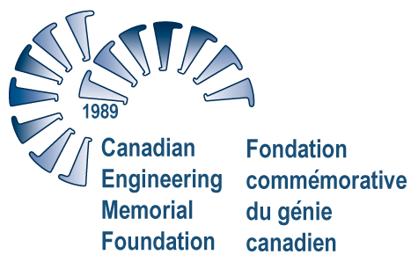
For immediate release November 7, 2007
New Hewlett-Packard Engineering Scholarships Ask
What Inspired You?

(Renfrew, Ontario): Hewlett-Packard has partnered with the Canadian Engineering Memorial Foundation to offer two new $2,500 scholarships to undergraduate women in engineering, with a focus on inspiration.

Applicants, who must be female students in an accredited Canadian engineering university program, will be asked what inspired them to enroll in engineering in the essay portion of the criteria.

“We want to know specifically what influences female students to pursue a career in engineering, whether it is a family member, a science and engineering camp, a teacher or a personal experience,” says Dan Marcek, Business Strategy Manager, Hewlett-Packard University Relations.

“By asking this question through a scholarship program, we reach two important objectives – we are supporting female students in their educational pursuits and we are gathering valuable information and insight into what factors motivate young women to become professional engineers.”

The Canadian Engineering Memorial Foundation (CEMF) currently offers a total of 16 scholarships for women in engineering at both the graduate and undergraduate levels of study.

All winners are selected based on leadership qualities and extra-curricular activities, rather than academics. Recipients must act as role models to encourage other women to pursue a career in engineering and must give a presentation about engineering to a pre-university audience.
Both of the new $2,500 HP scholarships will not require students to make a movie of their presentation as required for other higher value undergraduate CEMF scholarships.

HP is among the world’s largest IT companies, with a strong sense of corporate responsibility. During the last 20 years, HP has contributed more than $1 billion in cash and equipment to schools, universities, community organizations and other nonprofit organizations around the world.

- 30 -

Backgrounder Attached
For more information, contact: Meghan Howard, Assistant Executive Director, Canadian Engineering Memorial Foundation, 1-866-883-2363, info@cemf.ca or visit www.cemf.ca

