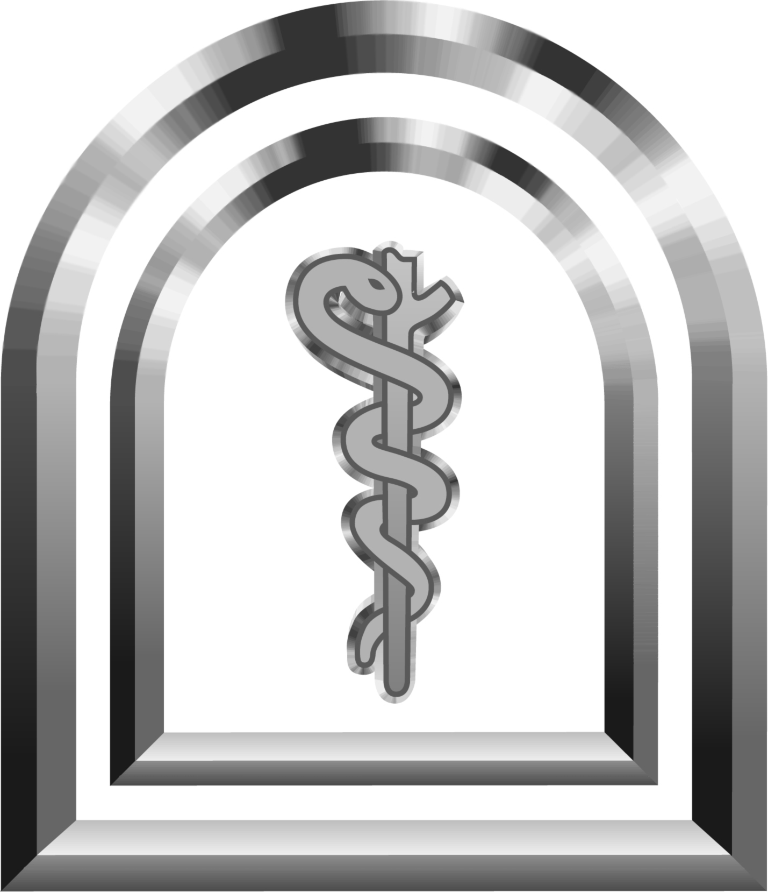

The Canadian Medical Hall of Fame / Pfizer Canada
Discovery Day in Health Sciences
The University of Western Ontario and Fanshawe College
Friday, May 9, 2008

Workshop Abstract Form ~ please print
Please fax this form to The Canadian Medical Hall of Fame 519-488-2999 by February 29, 2008.

Name of workshop coordinator
(Dr./Mr./Mrs./Ms. first name, last name)
Note: All communication regarding this workshop will be sent to this person unless otherwise directed
Position
Department and Institution
Mailing Address
(please include postal code)
Phone
Fax
Email

SAMPLE WORKSHOP
TITLE: The Human Brain and Muscle – How they work together
DESCRIPTION: In this workshop you will see a real human brain and talk about how it activates the muscles to contract. You will also see how the muscles themselves communicate with the brain and participate in a muscle contraction experiment
TITLE:
DESCRIPTION (2 to 4 sentence maximum):
Please be reminded that hands-on activities are preferred by students

Room / Lab / Building (to be booked by workshop coordinator):
Participation: | ◻ Morning 10:30 to 12:00 noon |  | ◻ Afternoon 1:00 to 2:30 | ◻ Both
Maximum # of student participants per session:
Names of workshop presenter(s)
(Dr./Mr./Mrs./Ms. first name, last name)
Note: These names will appear in our
workshop catalogue and all will receive a follow-up thank you letter mailed to the workshop coordinator for distribution

If you do not receive an email confirming receipt of your submission within two days or if you have any questions please contact Janice at The Canadian Medical Hall of Fame:
519-488-2003 / jmcnorgan@cdnmedhall.org

